1. Adding social media buttons on top (see alachuatemple.com) (mobile/)
   1. Facebook – https://www.facebook.com/KrishnaHouseColumbus
   2. YouTube – https://www.youtube.com/channel/UCbhrTLxLFZuH-n3Gz1HhJ-w?sub_confirmation=1
   3. Instagram - https://www.instagram.com/iskconcolumbus/
   4. More (button with down arrow)
      1. New temple – new.krishnatemple.co
      2. Temple newsletter – (help in setting up subscription form)
      3. Donate – take to Donation pages
      4. Login –
         1. Simple dropdown with ID, Password & login button
         2. Something like this .

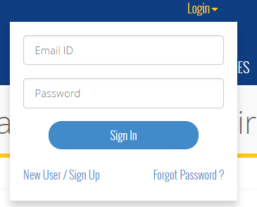

1. Menu bar (hamburger menu in mobile/tablet view)
   1. The menu bar (logo, hamburger menu, donation update, notification) should always stay on top of the screen even when user scrolls through the page till the bottom of page.
   2. When you click on any page in menu bar, it should close the menu and view page directly (currently if you click on any option from the menu, page is loaded below but menu doesn’t hide itself and show the pages)
   3. Add scroll to top button on each scrollable page
2. Side menu bar & Page size (desktop/tablet)
   1. Have a fixed height of side menu bar and all the pages, even though some pages may have less content, don’t shrink the menu bar or pages.
      1. #/dashboard/notifications – this page is too small that page’s height doesn’t match side bar’s height. In this case, page’s height should be same as side menu bar’s height. Followed
      2. Something like this… this image is only for reference to the size and location of sections. Do NOT worry about the content in this image. 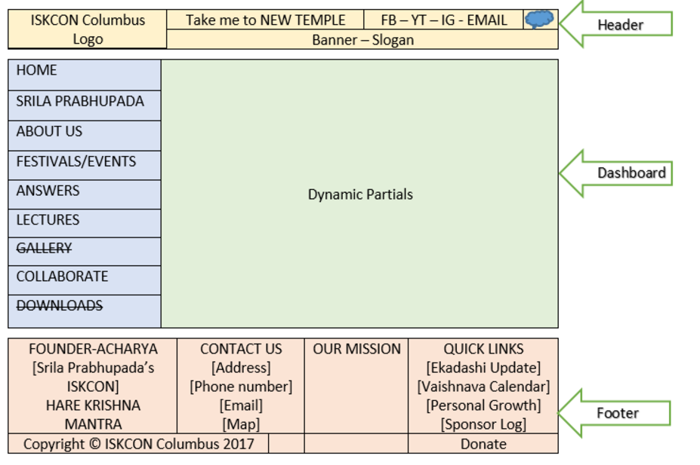
3. Footer
   1. Visible in all the pages
   2. Should be right after side menu and the page ends.
4. Admin login and access
   1. Not an extra page needed for login form, should be same page, one popup to fill id & password to login.
   2. We can hardcode the credentials like “admin & admin” for now, in a secured way as there are no DB tied up with this app.
   3. Once an admin logs in, following things should be allowed:
      1. Only Admins should be able to see the “edit” pencil icon. Image below. Regular users should only see “view details” link in the bubble-footer box.

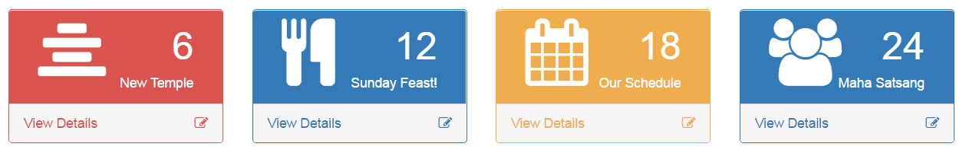

* + 1. On clicking the “edit” pencil icon, same popup will open as “view details” but with more content under model-body section like
       1. Modal-body
          1. Upload/remove image section
          2. Text box with formatting options (font style, size, bold italics, underline, etc)
       2. Modal-footer buttons
          1. Close (visible to both general users & admins)
          2. Save (visible to only admins)

Saves whatever image is uploaded/removed

Saves the text entered in the textbox

* + - * 1. Send email (visible to only admins)

Sends an email with everything as it is in modal-body section to [alek_modi@hotmail.com](mailto:alek_modi@hotmail.com)